SDA GIS Full Manual Review Methodology (December 2024)

*Written by Payman Alemi*

Table of Contents

1 ArcGIS Pro Portion 1

1.1 Initial Setup 1

1.2 Convert the eWRIMS flat file to a shapefile 4

1.3 Add the PLSS information from the BLM PLSS shapefile to the eWRIMS PODs 6

1.4 Filter to just the PODs in your watershed 9

1.4.1 Create a shapefile that just intersects the watershed 9

1.4.2 Relate the RR_Section_Intersect_BLM_2024 shapefile to the ewrims_statewide_pods_PLSS_spatial_join shapefile 10

1.5 Determine Edge Cases for Manual Review 15

1.5.1 Create the watershed boundary layer 15

1.5.2 Create the watershed interior buffer, interior, and exterior buffer layers 15

1.5.3 Eliminating Unnecessary PODs from the Manual Review 17

2 Manual Review Process using ArcGIS and Excel 19

2.1 Import the Manual Review POD List into Excel 19

2.2 Bulk Download all eWRIMS documents for your watershed 19

2.3 How to fill out the manual review spreadsheet 20

3 Appendix 25

3.1 Using Power Query and M Scripts 25

3.2 Using USGS StreamStats Tool 28

3.3 Using EarthPoint to convert Northings/Easting into Latitude/Longitude 30

3.4 Finding POD Coordinates in the absence of latitude/longitude and northing/easting 32

# ArcGIS Pro Portion

## Initial Setup

1. Create a local geodatabase just for this project, so that you have local storage space for you GIS files—this will substantially expedite processing in ArcGIS Pro. Normally, if you create a project in ArcGIS Pro, then ArcGIS Pro will automatically create an associated local geodatabase, which you can see in the *Contents* pane in Figure 1*.*

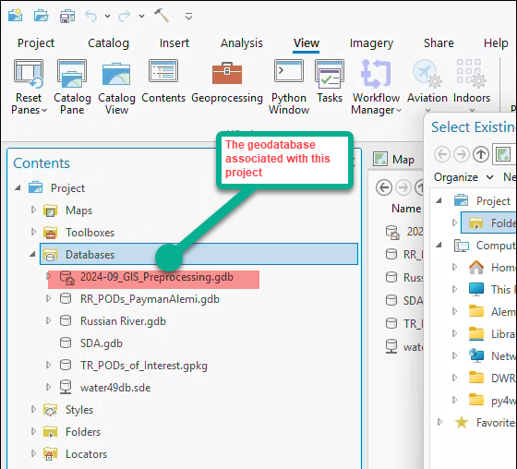

Figure . The geodatabase tied to the current project map.

1. Add the Flat_File_eWRIMS-YYYY-MM-DD.csv (“eWRIMS flat file”) generated by the GIS_POD_Flat_File_Prep.R script to your project map and to your local geodatabase.
2. Download the SDA_gdb.zip file provided to you by Supply and Demand Assessment (SDA) Unit staff. Right-click to unzip the file and save the entire geodatabase to your computer as SDA_gdb—keep it off of SharePoint and/or other cloud services to avoid syncing issues.
3. In ArcGIS Pro, navigate to the *View* pane and selec*t Catalog Pane* and scroll to *Databases:*

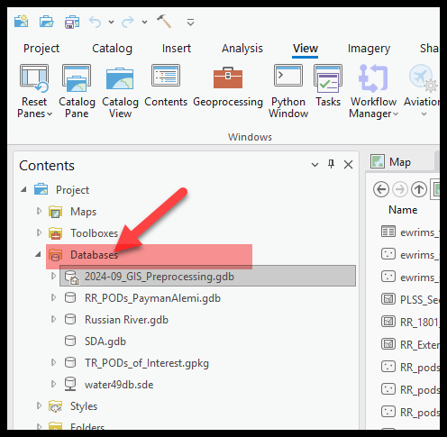

Figure . Database button in Catalog Pane.

1. Right-click on *Databases* and select *Add Database* from the pop-up menu:

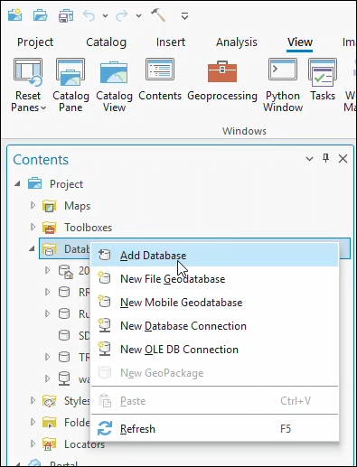

Figure . Adding an existing database in ArcGIS Pro.

1. Then navigate to *SDA.gdb* in the pop-up windows, click on it, and click *OK* to load it into your list of databases:

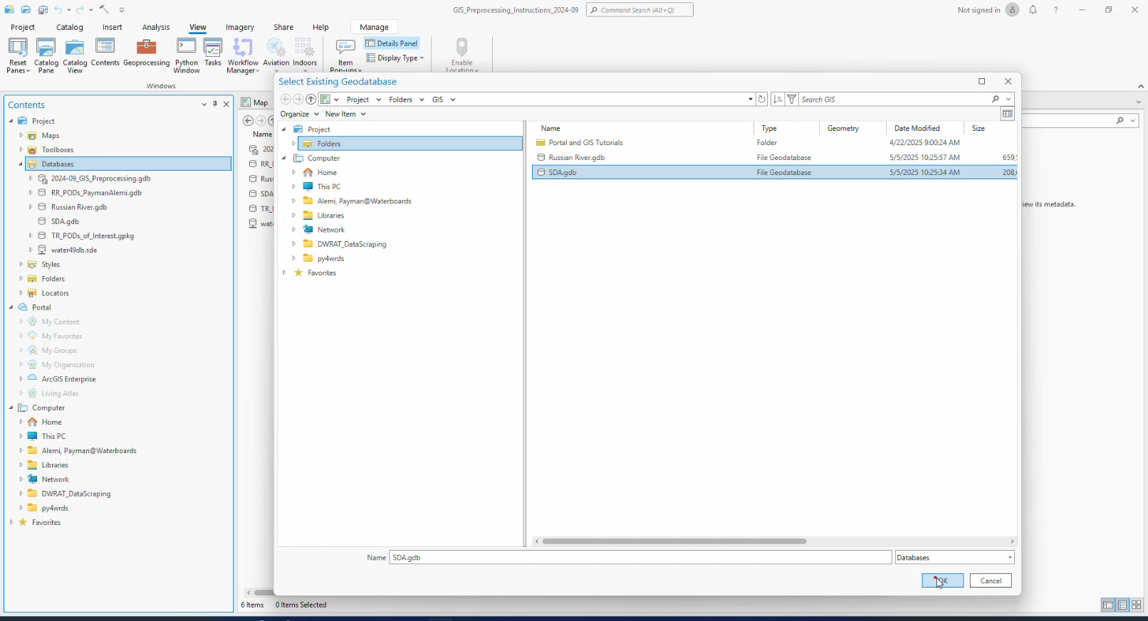

Figure . Select SDA.gdb from you saved location.

Navigate to *SDA.gdb* in your *Contents* menu and select (*PLSS_Sections_Fill_BLM_2024_NAD_1983)* to load to your project map and save it into *your_geodatabase.gdb.*

1. Add the BLM PLSS Quarter-Quarter sections shapefile (*WBGIS.PLSS_QQ_Sections*) from *SDA.gdb* to your project map and your local geodatabase.
2. Add the shapefile corresponding to your watershed from *SDA.gdb* to your project map and local geodatabase; for the Russian River, it’s *RR_1801_HUC8.*

## Convert the eWRIMS flat file to a shapefile

1. Run the *Export Table* Geoprocessing tool. This tool allows you to change the data types for the fields in the eWRIMS flat file. At the outset, the default data type for all fields is *text,* which will prevent us from applying the later steps.
   1. Find the tool by navigating to the **Analysis Pane**, clicking on the **Tools** icon, and then searching for *Export Table*. Select *Export Table (Conversion Tools) from* the resulting menu. I recommend adding the tool as a project favorite (right click and select “Add to my Favorites”), so you don’t have to search for it every time:

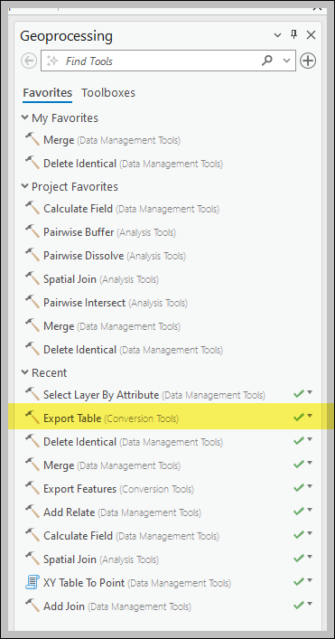

Figure . Export Table Tool

* 1. Enter these parameters into the *Export Table* tool:

**Input Table**: Flat_File_eWRIMS_YYYY-MM-DD.csv

**Output Table**: ewrims_flat_file_table (save this shapefile to your local geodatabase*).*

* 1. Click on the *Fields* button to expand the *Field Map*. Then click on individual fields as shown below to change the *type*.

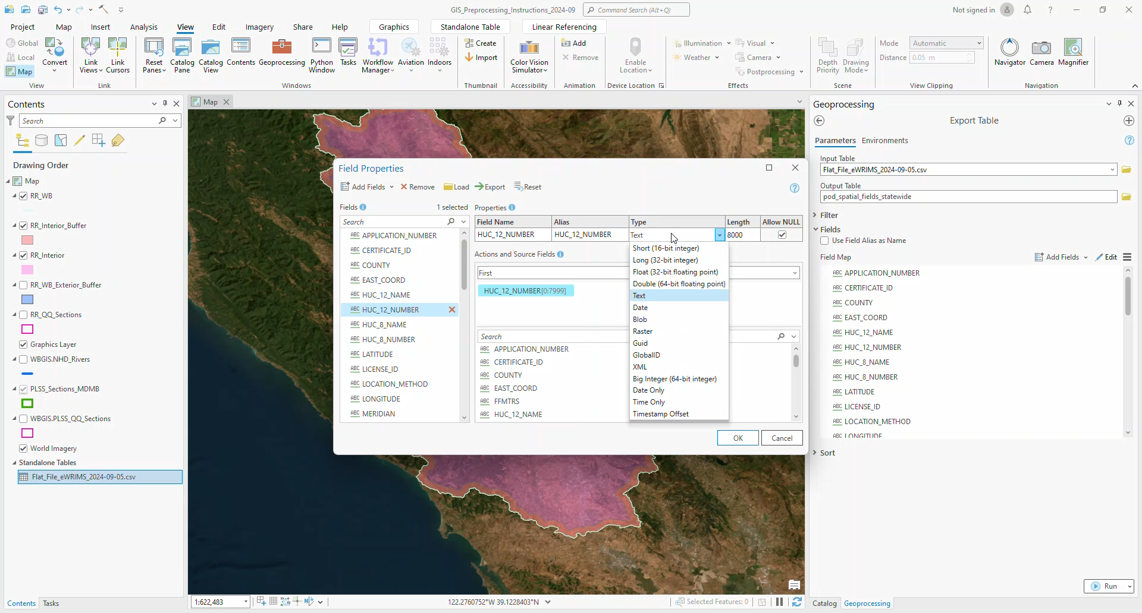

Figure . Adding Fields to an Attribute Table

* 1. Change these fields as follows:

**HUC12_NUMBER**: change type to Long (32-bit integer)  
**HUC8_NUMBER**: change type to Long (32-bit integer)  
**LATITUDE**: change type to Double (64-bit floating point)  
**LONGITUDE**: change type to Double (64-bit floating point)  
**RANGE_NUMBER**: change type to Short (16-bit integer)  
**SECTION_NUMBER**: change type to Short (16-bit integer)  
**TOWNSHIP_NUMBER**: change type to Short (16-bit integer)

* 1. Click *Run* to generate the shapefile

1. Run the *XY Table to Point* geoprocessing tool—this tool actually converts *ewrims_flat_file_table* into a shapefile.
   1. Analysis Pane à Tools à XY Table to Point (Data Management)
   2. Enter the following parameters and click *Run*—Figure 7 Figure 7. XY Table to Point Toolshows a screenshot for clarity, but the written instructions take precedent because it was impractical to retake a screenshot every time the instructions were slightly tweaked.

**Input Table:** ewrims_flat_file_table

**Output Feature Class:** ewrims_statewide_pods

**X Field:** LONGITUDE

**Y Field:** LATITUDE

**Z Field:** Leave blank

**Coordinate System: GCS_North_American_1983**—which you can click on the globe and navigate to select; it may appear with the alias *NAD 1983*.

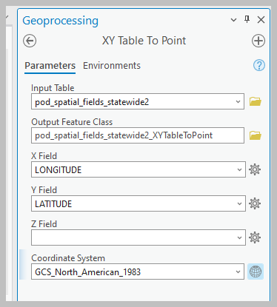

Figure . XY Table to Point Tool

## Add the PLSS information from the BLM PLSS shapefile to the eWRIMS PODs

1. Spatially join the PLSS BLM shapefile to the ewrims_statewide_pod shapefile
   1. Navigate to *Analysis à Toolsà Spatial Join (Analysis Tools)*
   2. Enter these parameters and click *Run.* The screenshot shows the tool’s appearance, but the written instructions below take precedent:

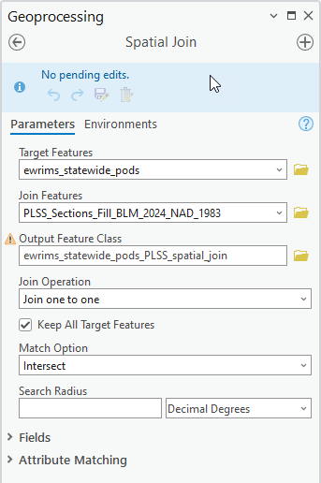

Figure . Spatial Join Tool

**Target Features**: ewrims_statewide_pods

**Join Features:** PLSS_Sections_Fill_BLM_2024_NAD_1983

**Output Feature Class:** ewrims_statewide_pods_PLSS_spatial_join

**Join Operation:** One to Many

**Checkmark**:Keep All Target Features

**Match Option**:Intersect

**Search Radius**: Leave the quantity field blank but select **Decimal Degrees** for the units.

1. Right-click on the *ewrims_statewide_pods_PLSS_spatial_join* shapefile and open the attribute table. Check that both the *MTRS* and *FFMTRS* fields are present.
2. Add the *MTRS_Match* field to the attribute table by clicking the *Add Field* button.

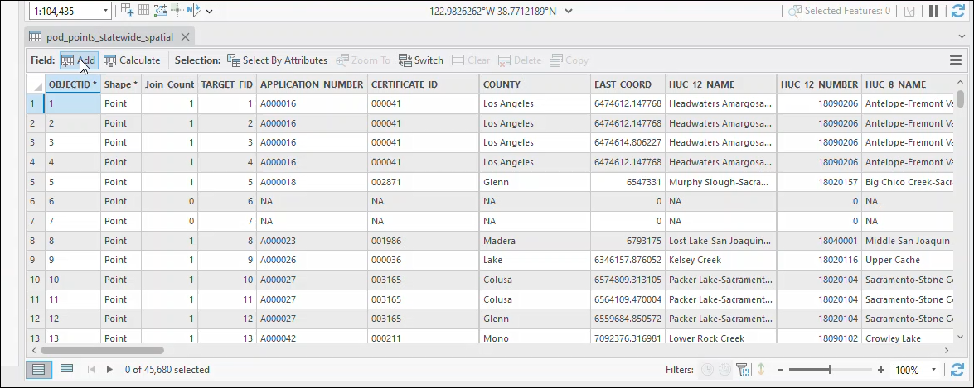

Figure . Add MTRS_Match Field

1. Then enter these parameters for the *Field Name, Alias,* and *Data Type* and save the changes to the attribute table.

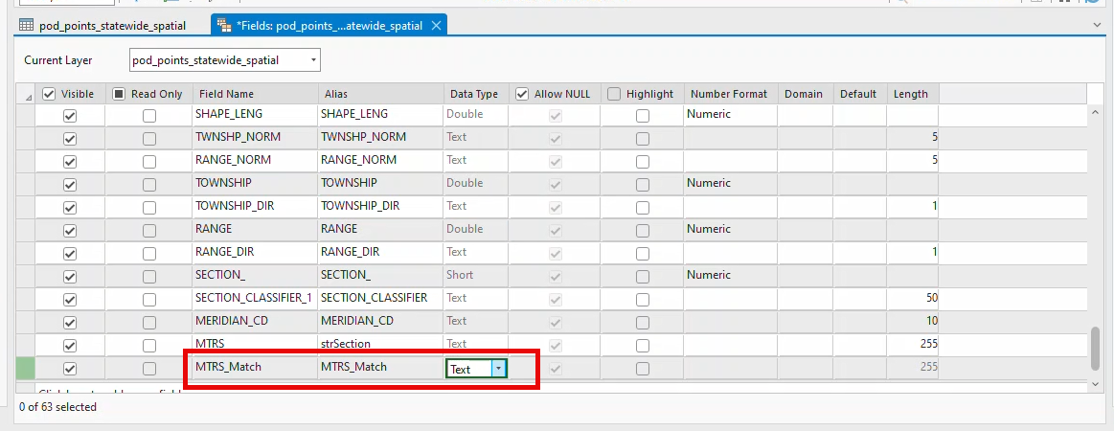

Figure . Field Properties of MTRS_Match

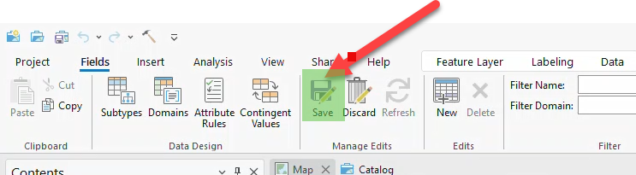

Figure . Saving changes to an attribute table

1. Back in the attribute table, right-click on the *MTRS_Match* field, and click on *Calculate Field:*

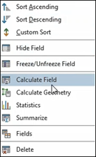

Figure . Calculate Field for MTRS_Match

1. Calculate **MTRS_Match** by using the Python expression below and set the data type to text; otherwise, the field calculator will fail.

Select *Python* as the **Expression Type.** Toggle on the *Enable Undo button* in case the code fails and click *Ok.*

**MTRS_Match =**  reclass(!FFMTRS!,!MTRS!)

**Code Block**

def reclass(FFMTRS, MTRS):

if FFMTRS == MTRS:

return "Y"

else:

return "N"

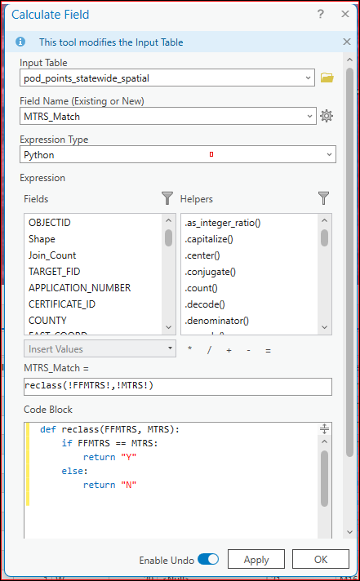

Figure . Python code block for MTRS_Match

## Filter to just the PODs in your watershed

You can apply the steps in this section to any watershed. Just use the shapefiles that correspond to your watershed instead, but the sequence is the same. The example here uses the Russian River watershed.

### Create a shapefile that just intersects the watershed

1. Select*PLSS_Section_Fill_BLM_2024_NAD_1983*by location: *Map à Select by Location*
2. Enter these parameters into the *Select by Location* wizard and click *OK.*

*Input Features:* PLSS_Sections_Fill_BLM_2024_NAD_1983

*Relationship*: Intersect

*Selecting Features*: RR_1801_HUC8 (or the polygon shapefile that represents your watershed)

*Search Distance:* Leave the quantity blank and enter **Decimal Degrees** for the units

*Selection:* New Selection

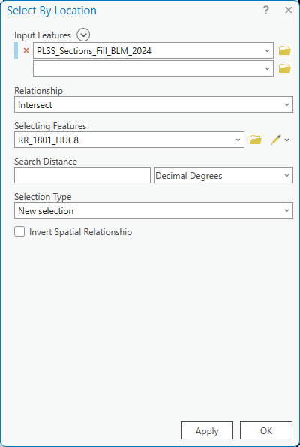

Figure . Select by Location to your watershed

1. The portion of the PL*SS_Sections_Fill_BLM_NAD_1983* shapefile that overlaps with the *RR_1801_HUC8* shapefile should be selected. Right-click on the *PLSS_Sections_Fill_BLM_NAD_1983* shapefile in the Contents pane and click on *Selection à Make Layer from Selected Features.*
2. Rename the newly created layer *RR_Section_Intersect_BLM_2024.*
3. Save *RR_Section_Intersect_BLM_2024* to your local geodatabase.

### Relate the RR_Section_Intersect_BLM_2024 shapefile to the ewrims_statewide_pods_PLSS_spatial_join shapefile

1. Right-click **RR_Section_Intersect_BLM_2024** and navigate to *Joins and Relates à Add Relate*
2. Input these parameters into the *Add Relate* wizard and click *OK:*

*Layer Name: or Table View:* RR_Section_Intersect_BLM_2024

*Input Relate Field:* PLSS_MTRS (alias = MTRS)

*Relate Table:* ewrims_statewide_pods_PLSS_spatial_join

*Output Relate Field:* MTRS

*Relate Name:* MTRS_Relate

*Cardinality:* One to many

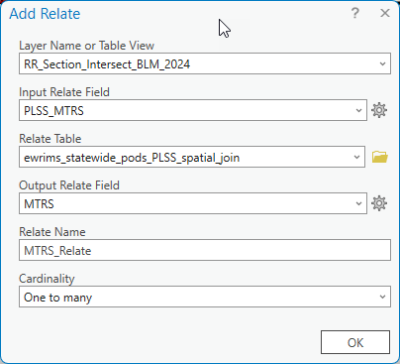

Figure . Adding MTRS_Relate

1. Right-click on the*RR_Section_Intersect_BLM_2024_BLM_2024*layer in the *Contents* pane and go to *Propertiesà Selection*
   1. Check the box to *automatically select related data*
   2. Click ok:

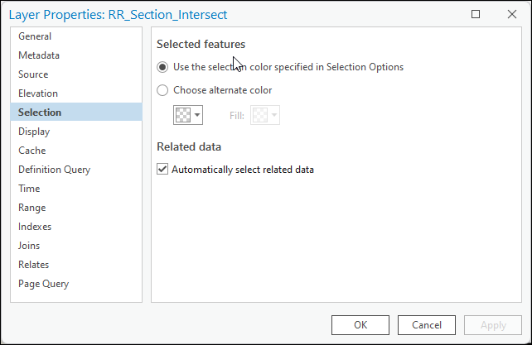

Figure . Automatically selecting related data

1. Create *RR_pods_MTRS_Relate* shapefile
   1. Right-click the *RR_Section_Intersect_BLM_2024* layer in the *Contents* pane and click on the *Attribute Table.*
   2. Select all the polygons in the *RR_Section_Intersect_BLM_2024* layer by clicking anywhere on the attribute table and clicking **Ctrl+A** on your keyboard.
   3. Since we checked the *Automatically select related data* checkbox earlier, all the related PODs in the *ewrims_statewide_pods_PLSS_spatial_join* layer will also be selected.
   4. Right-click the *ewrims_statewide_pods_PLSS_spatial_join* layer in the *Contents* pane and go to *Data à Export Features*
   5. Toggle on the *Use the selected records* button and export the feature class as *RR_pods_MTRS_Relate* to your local geodatabase. Click *Ok* at the bottom of the dialog box. Hit *OK.*

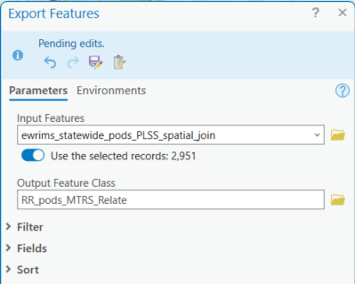

Figure . Creating the RR_pods_MTRS_Relate layer

* 1. Clear all selections from your ArcGIS Pro project.

1. **Create the *RR_pods_FFMTRS_Relate* shapefile**

Select PODs where the *FFMTRS* field in *ewrims_statewide_pods_PLSS_spatial_join* matches the *PLSS_MTRS* field in the *RR_Section_Intersect_BLM_2024* shapefile.

* 1. Right-click on the *ewrims_statewide_pods_PLSS_spatial_join* shapefile and go to *Joins and Relates à Remove All Relates*.
  2. Right-click on the *RR_Section_Intersect_BLM_2024*shapefile and remove all the relates.
  3. Right-click on the *RR_Section_Intersect_BLM_2024* shapefile and go to *Propertiesà Selection*. Underneath the *Related Data* section, ensure that the *Automatically select related data* checkbox is still checked.
  4. Right-click on the *RR_Section_Intersect_BLM_2024* again and go to *Joins and Relatesà Add Relate* and enter these parameters, and then click *OK*.

*Layer Name or Table View:* RR_Section_Intersect_BLM_2024

*Input Relate Field:* PLSS_MTRS (alias = MTRS)

*Relate Table:* ewrims_statewide_pods_PLSS_spatial_join

*Output Relate Field:* FFMTRS

*Relate Name:* FFMTRS_Relate

*Cardinality:* One to Many

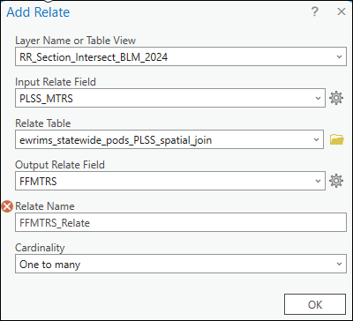

Figure . Creating FFMTRS_Relate

* 1. Open the attribute table of the *RR_Section_Intersect_BLM_2024* shapefile and select all the polygons.
  2. Right-click on the *ewrims_statewide_pods_PLSS_spatial_join* shapefile and go to *Data à Export Features*
     1. Toggle on the *use selected records* button and export as *RR_pods_FFMTRS_Relate* to your local geodatabase.

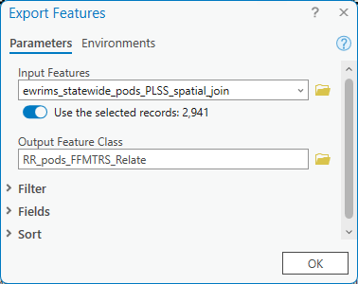

Figure . Creating the RR_pods_FFMTRS_Relate layer

* 1. Clear all the selections from your ArcGIS Pro project.

1. Merge the *RR_pods_MTRS_Relate and RR_pods_FFMTRS_Relate* shapefiles.
   1. Go to the *Analysis Pane* and navigate to the *Merge (Data Management Tools)* tool and enter these parameters:

*Input datasets:* RR_pods_FFMTRS_relate, RR_pods_MTRS_relate

*Output dataset:* RR_pods_merged

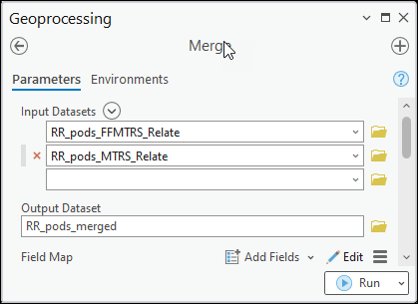

Figure . Merge (Data Management Tools) Tool

The total records should be the sum of the records in the attribute tables of the two layers.

1. Delete identical records from the *RR_pods_merged* shapefile with the *Delete Identical (Data Management Tools)* tool based on the *POD_ID* field:

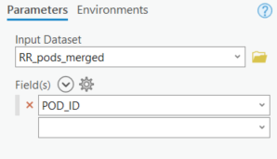

Figure . Delete Identical (Data Management Tools) Tool

1. You have now captured all PODs that geospatially may be located in the Russian River watershed. As of 12/8/2024, this series of steps yield 2,931 PODs in the *RR_pods_merged* shapefile. Due to the infeasibility of reviewing all 2,931 PODs, SDA recommends whittling down the list to edge cases as indicated in the next section.
2. Add a new text field, *Keep_POD*, to the attribute table of the *RR_pods_merged shapefile*.
3. Export the attribute table of the *RR_pods_merged* shapefile as a csv and add a datestamp as the suffix, e.g., *RR_pods_merged_2024-12-18.csv*, into the *DWRAT_DataScraping/Demand/OutputData* folder. This CSV will serve as the full list of possible PODs for your watershed and after you finish your manual review, you will remove the out of watershed PODs from this CSV to create your final watershed POD List.

## Determine Edge Cases for Manual Review

### Create the watershed boundary layer

1. Load the *RR_1801_HUC8* shapefile from the SDA GIS geodatabase. If you are creating a boundary polyline for another watershed, then the corresponding HUC8 or HUC12 shapefile. The remaining steps are identical for other watersheds.
2. Navigate to the *Analysis Paneà Tools* and search for *Polygon to Line.* This tool is only licensed for use in **ArcGIS Pro – Advanced**.
3. Enter these parameters and click *Run:*

*Input Features:* RR_1801_HUC8 (or your watershed polygon)

*Output Feature Class:* RR_WB (save to your local geodatabase)

*Checkmark Identify and store polygon neighboring information.*

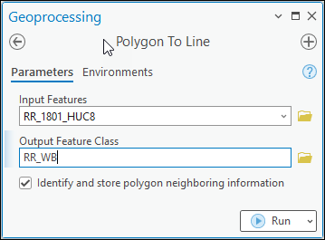

Figure . Polygon To Line Tool

### Create the watershed interior buffer, interior, and exterior buffer layers

1. Navigate to the *Analysis Paneà Tools,* search for the *Pairwise Buffer (Analysis Tools)* tool.
2. Enter the following parameters and click *Run:*

*Input Features:* RR_WB

*Output Feature Class*: RR_WB_Buffer and save to your local geodatabase.

*Distance [value or field]:*  Linear Unit, 1, Statute Miles

*Method:* Planar

*Dissolve Type:* No Dissolve

*Maximum Offset Deviation: 0, Decimal Degrees*

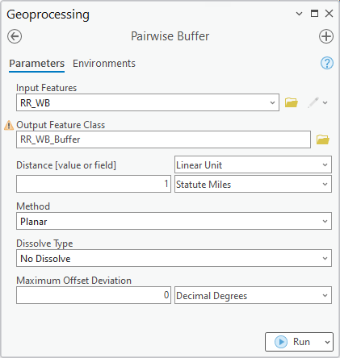

Figure . Pairwise Buffer (Analysis Tools) Tool

1. Navigate to the *Analysis Paneà Tools* and search for *Union.* Click on the *Union (Analysis Tools)* tool.
2. Enter these parameters and click *Run:*

*Input Features:* RR_WB_Buffer (or the buffer layer you created for your watershed), RR_1801_HUC8 (or the polygon shapefile for your watershed)

*Ranks:* Leave blank

*Output Feature Class:* RR_WB_Buffer_Union (save to your local geodatabase)

*Attributes to Join:* All attributes

*Gaps Allowed:* Check the box

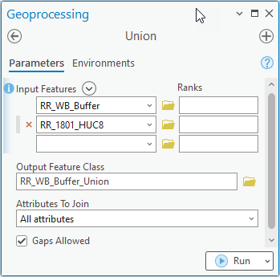

Figure . Union (Analysis) Tools

1. Right-click on the *RR_WB_Buffer_Union* shapefile in the *Contents* pane and open the attribute table.
2. There should be 3 records in the attribute table (highlight each row to identify which is which):
   1. **Optional:**1 record that corresponds to the 1-miles sliver surrounding the Russian River boundary. Export this record as a separate layer, *RR_WB_Exterior_Buffer* to your local geodatabase.
   2. **Mandatory:** 1 record that corresponds to the 1-mile sliver within the Russian River boundary. Export this record as a separate layer, *RR_WB_Interior_Buffer*, to your local geodatabase.
   3. **Mandatory:** 1 record that corresponds to the interior polygon within the Russian River watershed, 1 mile smaller on every side than the watershed itself. Export this record as a separate shapefile, *RR_WB_Interior*, to your local geodatabase.

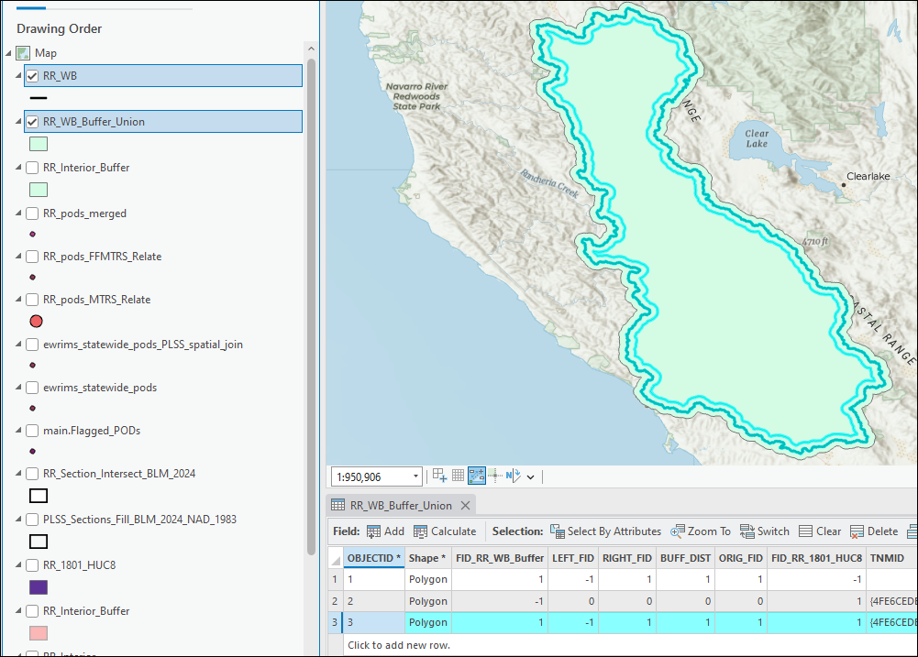

Figure . In this image, the “RR_WB_Interior_Buffer” record is selected.

### Eliminating Unnecessary PODs from the Manual Review

1. Right-click in the Contents pane on the *RR_pods_merged* shapefile and open the attribute table. Add a new field with the name and alias *Case* and data type *Short* into the attribute table.
2. Go to the *Analysis tabà Tools à Select Layer by Location* tool
3. Enter these parameters and click *Run* to execute:

*Input Features:* RR_pods_merged

*Relationship:* Intersect

*Selecting Features: RR_WB_Interior*

*Search Distance:* Blank and Decimal Degrees

*Selection Type:* New Selection

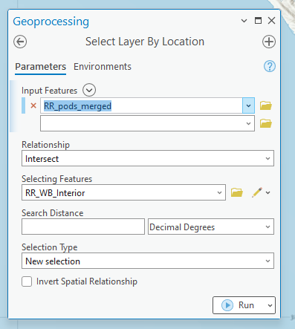

Figure . Select Layer by Location Tool

1. Once the selection is complete, open the attribute table of the *RR_pods_merged* shapefile and locate the *Case* field.
2. Use the field calculator to update the *Case* field value to 0 for the selected points
   1. Make sure “Use the selected records” is toggled on.
3. Run a **definition query** to exclude all Case 0 records from RR_pods_merged
   1. Right click layer > properties > Definition Query > Add new
   2. Define your query such that Where *Case* *is null*

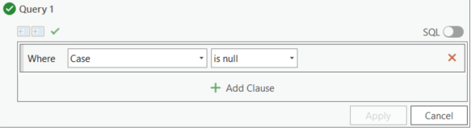

Figure . Definition Query for null cases

1. Export the selected records as a new shapefile, *RR_pods_manual_review1*.
2. Add a definition query to *ewrims_statewide_pods_PLSS_spatial_join* to search for any records where:
   1. TRIB_DESC begins with *Russian* OR
   2. WATERSHED begins with *Russian* OR
   3. SOURCE_NAME begins with *Russian*
3. After activating the definition query, export the records in the *ewrims_statewide_pods_PLSS_spatial_join* attribute table to a new shapefile, *RR_pods_manual_review2*, in your local geodatabase.
4. Merge *RR_pods_manual_review1* and *RR_pods_manual_review2* into a single shapefile, *RR_pods_manual_review* by using the *Merge* tool.
5. Delete the identical records from RR_pods_manual_review based on the *POD_ID* field.
6. Export *RR_pods_manual_review* as a CSV, *RR_pods_manual_review.csv* to the *DWRAT_DataScraping/Demand//OutputData* folder.

# Manual Review Process using ArcGIS and Excel

## Import the Manual Review POD List into Excel

1. Create an xlsx file within your *DWRAT_DataScraping/Demand/OutputData* folder called *RR_pods_manual_review.xlsx*.
2. Import *RR_pods_manual_review.csv* into *RR_pods_manual_review.xlsx* (“manual review spreadsheet”) by using Power Query—refer to *Appendix 3.1 Using Power Query and M Scripts*.
3. Navigate to the *RR_GIS_Manual_Review_M_Script.txt* (M Script”) file in the *Scripts* folder of your *DWRAT_DataScraping/Demand* GitHub sub-repository and open it in Notepad++.
4. Copy and paste all the content from the *M Script* into the Advanced Editor in Power Query.
5. Confirm there are no syntax errors and click *Done.*
6. The *M script* makes a bunch of changes to the original CSV that you should see reflected in Power Query:
   1. LATITUDE gets renamed to ewrims_latitude
   2. LONGITUDE gets renamed to ewrims_longitude
   3. SOURCE_NAM gets renamed to ewrims_SOURCE_NAME
   4. TRIB_DESC gets renamed to ewrims_TRIB_DESC
   5. WATERSHED gets renamed to ewrims_WATERSHED
   6. COUNTY gets renamed to ewrims_COUNTY

The *M Script* also addsthe following fields:

* 1. Report_Latitude
  2. Report_Longitude
  3. Report_Northing
  4. Report_Easting
  5. Report_Zone
  6. Report_County
  7. Report_Source Creek
  8. Report_Tributary
  9. Report_Thence
  10. Report_APN
  11. Report_Township
  12. Report_Range
  13. Report_Section
  14. Report_QSection
  15. Report_QQSection
  16. Report_POD_Information
  17. LATITUDE
  18. LONGITUDE
  19. StreamStats
  20. Keep_POD
  21. POD_Justification

1. After you apply the M Script with Power Query, export the resulting query as the “[ID]_GIS_Manual_Review” sheet within your spreadsheet.

## Bulk Download all eWRIMS documents for your watershed

1. Create a *Reports* child folder (if it hasn’t already been created)within your *DWRAT_DataScraping/Demand/InputData* folder. Replace [Watershed] with your watershed name, e.g., *Navarro*. The *eWRIMS_Document_Bulk_Downloader.R* script will save all the eWRIMS documents for your watershed to this folder if you follow the remaining steps in this subsection.
2. Open *Demand.Rproj* with RStudio.
3. Navigate to your local version of the *DWRAT_DataScraping* GitHub repository.
4. Open the *Watershed_Demand_Datasets_Paths.xlsx* spreadsheet from the *DWRAT_DataScraping/Demand/InputData* folder.
   1. Scroll to the*GIS_Preprocessing* section of the spreadsheet and fill out this field:
      1. **EWRIMS_REPORTS_FOLDER_PATH**—Enter the full file path for your *Reports* folder.
   2. Save and close the spreadsheet.
5. Navigate to the *eWRIMS_Document_Bulk_Downloader.R* script and run the entire script. The script is designed to skip any reports that have already been downloaded for your watershed. Consequently, you won’t waste time if you have to pause the script halfway—when you resume, the script will just pick up where you left off. It is unlikely that the number of PDFs in your *Reports* folder will perfectly match the number of PODs in *RR_pods_merged_2024-12-18.csv (your full POD list)*  because:
   1. Some water rights have multiple PODs and there is only 1 eWRIMS PDF document for each water right.
   2. A few water rights only have a paper record that has not been scanned into eWRIMS yet.
   3. A few water rights have corrupt PDFs.

## How to fill out the manual review spreadsheet

1. Now that you have downloaded the eWRIMS PDFs, you can begin the manual review by referring to the PDF for each water right to fill out the various *report fields.* The figures below demonstrate where to look for each *report field.*

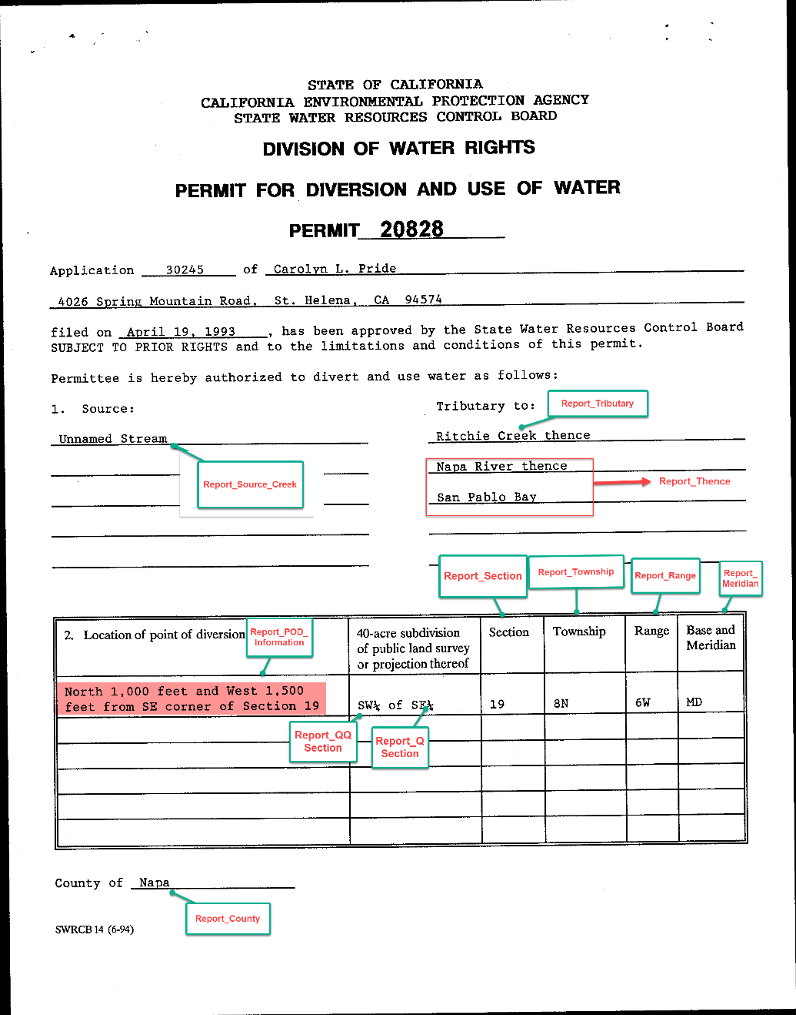

Figure . Locating the Report Fields on an eWRIMS document (Part 1)

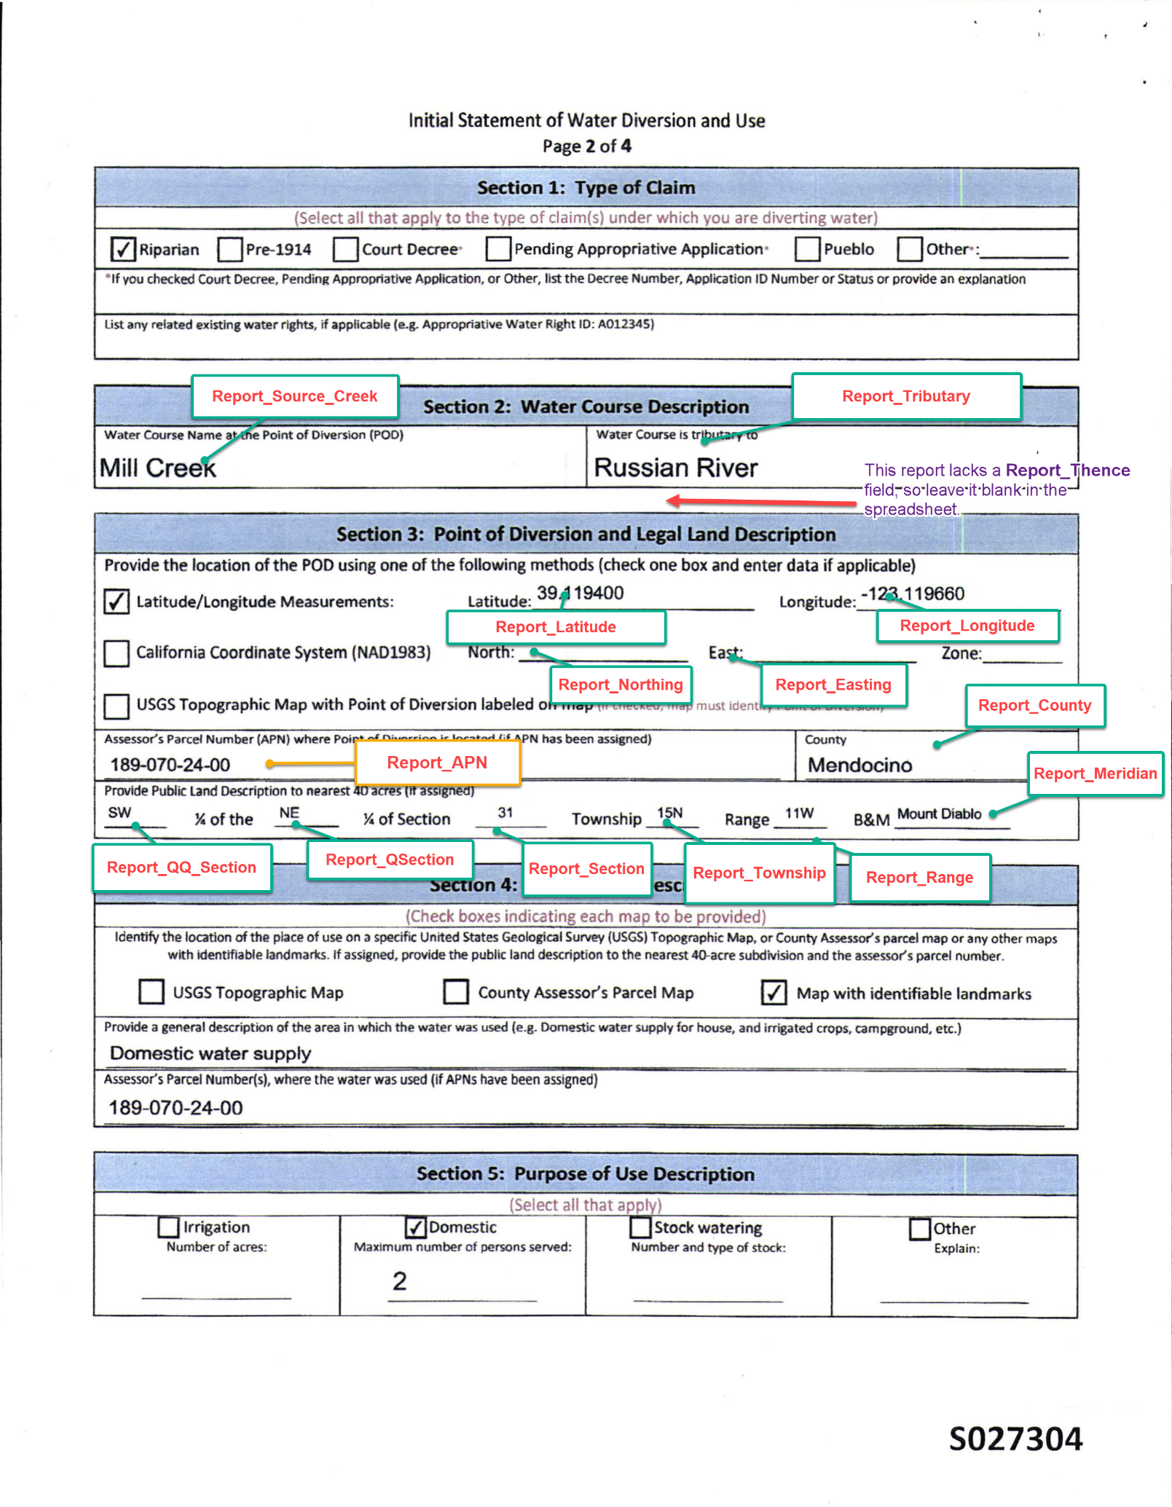

Figure . Locating the Report Fields on an eWRIMS document (Part 2)

1. Note that not all eWRIMS PDFs have the same design—the water rights form has evolved over the years and different types of rights have different fields. Additionally, even after you apply optical character recognition (OCR) to these PDFs, you still may be unable to apply Ctrl+ F to search for terms because of poor scan quality, especially for older water rights forms. Furthermore, you also do not need to fill out every single field that you added to your manual review spreadsheet with the *RR_GIS_Manual_Review_M_Script (*hosted in the *DWRAT_DataScraping/Demand/Scripts* folder)*.* If the report already explicitly states the latitude and longitude of the PODs, then you do NOT need to note all the other *supplemental* geolocational information. The purpose of this supplemental information is to derive the POD latitude and longitude if absent from the report.
2. **Filling out the Fields in the Manual Review Spreadsheet**
3. *Report_Latitude* and *Report_Longitude:* If the eWRIMS report has the latitude and longitude, then fill out these two fields. If the coordinates are not provided in decimal degrees, then convert them to decimal degreesbefore entering them into the spreadsheet. The purpose of these fields is to gauge the accuracy of the eWRIMS GIS coordinates (*eWRIMS_Latitude and eWRIMS_Longitude)—*if eWRIMS_Latitude and eWRIMS_Longitude are accurate, then set the LATITUDE and LONGITUDE fields in the manual review spreadsheet equal to eWRIMS_Latitude and eWRIMS_Longitude. If they are inaccurate, then instead populate the LATITUDE and LONGITUDE fields with the *Report_Latitude and Report_Longitude.*
4. *Report_Northing* and *Report_Easting:* Northings and eastings are coordinates in the state plane coordinate system. The California version of the state plan coordinate system is known as the *California Coordinate System.* If the eWRIMS report lacks the *Report_Latitude* and *Report_Longitude* fields, then look for the *Report_Northing* and *Report_Easting*. Check that the diverter reported the northing and easting in units of feet and note the *Report_Zone* as well. The *Report_Zone* is always established with respect to a coordinate reference system (CRS), although this CRS may not be explicitly stated.

**Explicit CRS example**

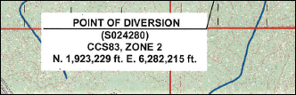

*Figure 30.* CCS83, ZONE 2 indicates that the CRS is NAD 1983—the CCS is short for California Coordinate System.

**Report_Zone with no CRS**

Occasionally reports do not indicate the CRS (Payman Alemi was unable to find an example after a cursory search but has seen it happen before). However, the CRS can usually be determined based on context. Northing and easting can be provided with either NAD 1927 or NAD 1983 CRS, but if you convert both sets of coordinates into WGS 84 and plot them in ArcGIS Pro against your watershed polygon shapefile, you can determine which CRS makes more sense. If no *Report_Zone* is listed in the report, then you will need to rely on other geolocational parameters to back-calculate the *Report_Latitude* and *Report_Longitude.* For detailed instructions on this back-calculation process, refer to Appendix *3.3.*

1. *Report_Source_Creek*, *Report_Tributary*, and *Report_Thence* fields: The purpose of filling out these fields is to assess whether the POD flows into a stream that belongs to the watershed of interest. If none of these fields have “Russian River” for example, then it is likely that the POD flows into another watershed. As an extra check, enter the *Report_Latitude and Report_Longitude* into the USGS StreamStats tool.
2. *Report_Meridian, Report_APN, Report_Township, Report_Range, Report_Section, Report_QSection, Report_QQSection, and Report_POD_Information* are only necessary to populate when the report lacks any type of POD coordinates, or you suspect that the coordinates are incorrect. Additionally, not every report may have all these fields, but even with a handful of them, you can roughly pinpoint the POD coordinates by using ArcGIS Pro. Appendix *3.4* provides a detailed example of this process by using the POD for water right A028127.

In a nutshell, the steps above safeguard against the possibility that the coordinates in eWRIMS were radically misplotted—our ArcGIS Pro analysis has already determined that the eWRIMS GIS coordinates are located within the watershed. However, if the report coordinates differ substantially from the eWRIMS GIS coordinates, we must check that they are still located within the watershed. If they are NOT located within the watershed, then type “No” in the *Keep_POD* field in the manual review spreadsheet because we want to exclude these PODs from the final demand dataset.

1. *StreamStats* field—Fill out this field with “In watershed” or “Outside watershed” depending on the results of the USGS StreamStats Tool *(see Appendix 3.2)* The purpose of this field is to catch PODs that are geospatially within the watershed but that flow into another watershed—this is rare but possible. All “outside watershed” records should have their corresponding *Keep_POD* field set to “No” because they should also be excluded from the final demand dataset.
2. *Keep_POD:* Indicate as “Yes” or “No”—you either keep the POD or exclude it from the final POD list for the watershed.
3. *POD_Justification:* Justify your decision to keep or exclude the POD and be as detailed as possible (cite coordinate system discrepancies and other issues you came across for example)
4. *Staff:* Type your name.
5. *Review_Date:* Type the date you conducted the manual review for the POD.
6. Keep in mind that the manual review spreadsheet that you created from ArcGIS Pro contains only a subset of the PODs in the watershed—this is the subset that might possibly have geolocational errors. Consequently, you need to remove the errant PODs you identified in the previous steps from the full POD list in *RR_pods_merged_2024-12-18.csv*.
   1. Using Power Query, import *RR_pods_merged_2024-12-18.csv* into your *manual review spreadsheet.*
   2. Remove all PODs from the *RR_pods_merged_2024-12-18* sheet that were identified for removal during the manual review process and save this filtered list as a separate sheet called *Final_List.*
7. Type the full name of the *[ID]_GIS_Preprocessing.xlsx* spreadsheet and the *Final_List* in *Watershed_Demand_Datasets_Path*.xlsx:
   1. POD_APPLICATION_NUMBER_SPREADSHEET_PATH: this is the file path of your manual review spreadsheet.
   2. POD_APPLICATION_NUMBER_WORKSHEET_NAME: set to “Final_List”
   3. IS_SHAREPOINT_PATH_POD_APPLICATION_NUMBER_SPREADSHEET: set to “FALSE”.
8. You can now jump to ***Section 7. Preliminary Demand Dataset*** of the main [Demand Dataset Procedure](https://cawaterboards.sharepoint.com/:w:/g/DWR/SDA/EQDXmNHY4TpOsmF2CBTNM3wBwEwVeYEYhaz-S9_46h-GiA?e=r7J4eQ) document.

# Appendix

## Using Power Query and M Scripts

1. Navigate to *Data à Get Data à Launch Power Query Editor*

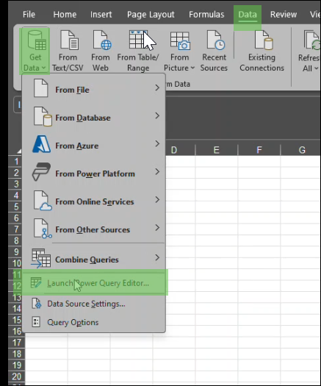

Figure . Launch Power Query Editor

1. Navigate to the *Home Tab àNew Sourceà Fileà Text/CSV* and load *[_pods_manual_review.csv* by clicking *Import* and then *OK* on the resulting dialog boxes.

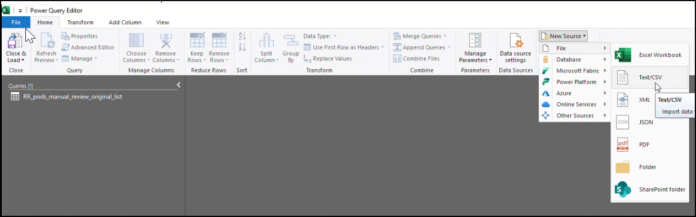

Figure . Importing CSVs into Power Query

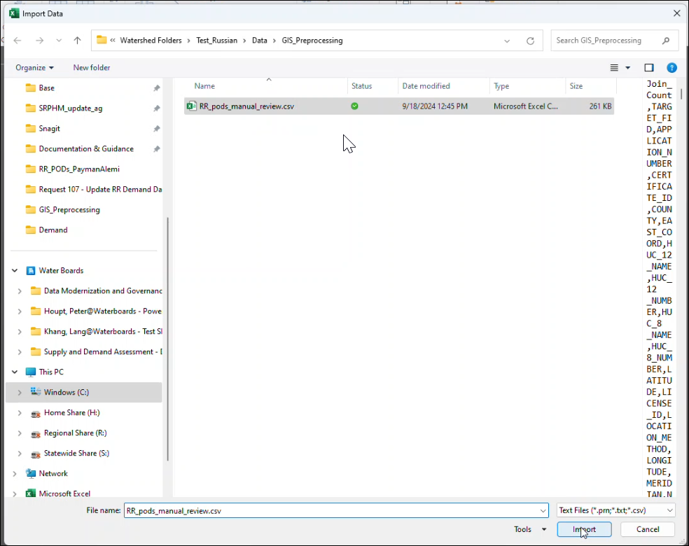

Figure . Import Data Window

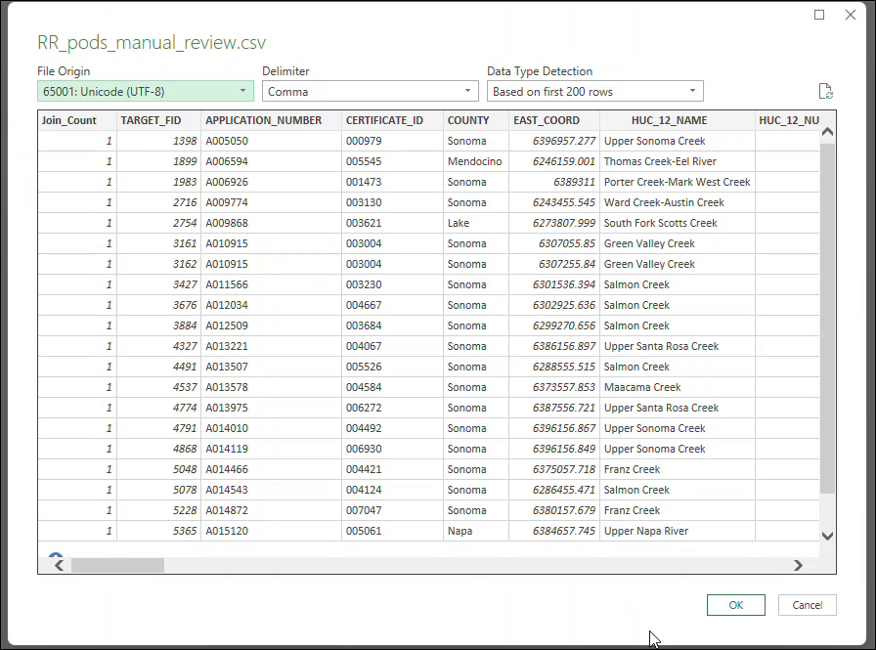*Figure 34. Loading RR_pods_manual_review.csv into Power Query Editor*

1. Rename the CSV (“query”) that you just imported to *[WS]_pods_manual_review_original* (“RR_pods_manual_review_original”in this example) by right-clicking on it.

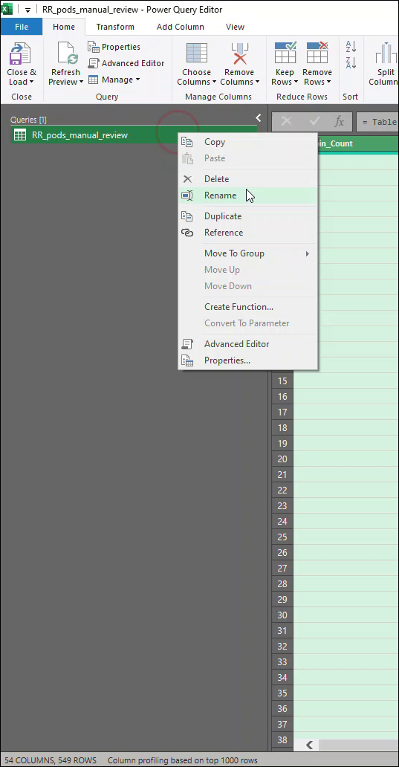

Figure . Renaming the query

1. Right-click on the query again and select *Advanced Editor*.
2. Delete everything from the resulting *Advanced Editor* window:

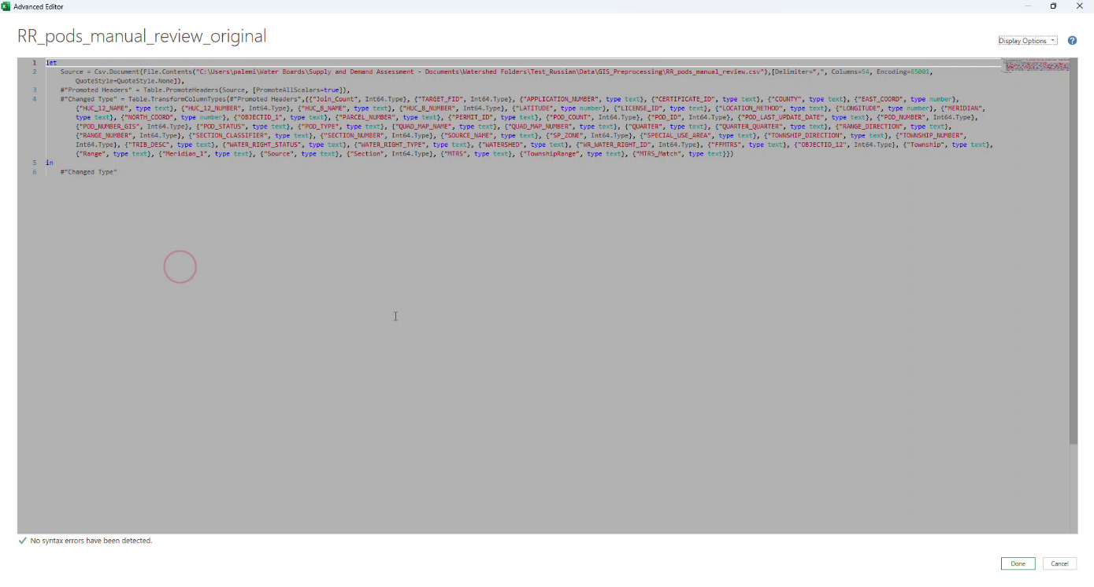

Figure . Advanced Editor in Power Query Editor

1. Load the M script of interest (“RR_GIS_Manual_Review_M_Script.txt” in this example) in Notepad++.
2. Copy and paste all the content from the M Script into the *Advanced Editor* window.
3. Adjust the portion of the M Script that defines the local user folder to point to yours:

let

Source = Csv.Document(File.Contents("C:\Users\palemi\Water Boards\Supply and Demand Assessment - Documents\Watershed Folders\Test_Russian\Data\GIS_Preprocessing\RR_pods_manual_review.csv")

1. Confirm there are no syntax errors and click *Done.*
2. Load the query as a sheet with the same name into Excel by navigating to *Home🡪 Close and Load* in the ribbon.

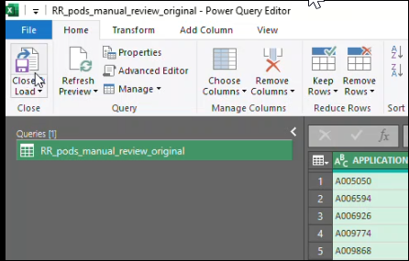

Figure . Close and Load the query

## Using USGS StreamStats Tool

* 1. Go to <https://streamstats.usgs.gov/ss/> and enter the latitude and longitude of the POD of interest into thesearch box:

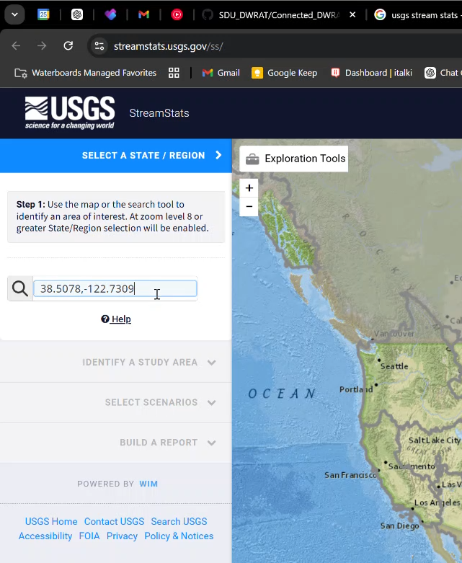

Figure . Entering Coordinates in StreamStats

* 1. Then select the automatic coordinates that appear in the dropdown menu:

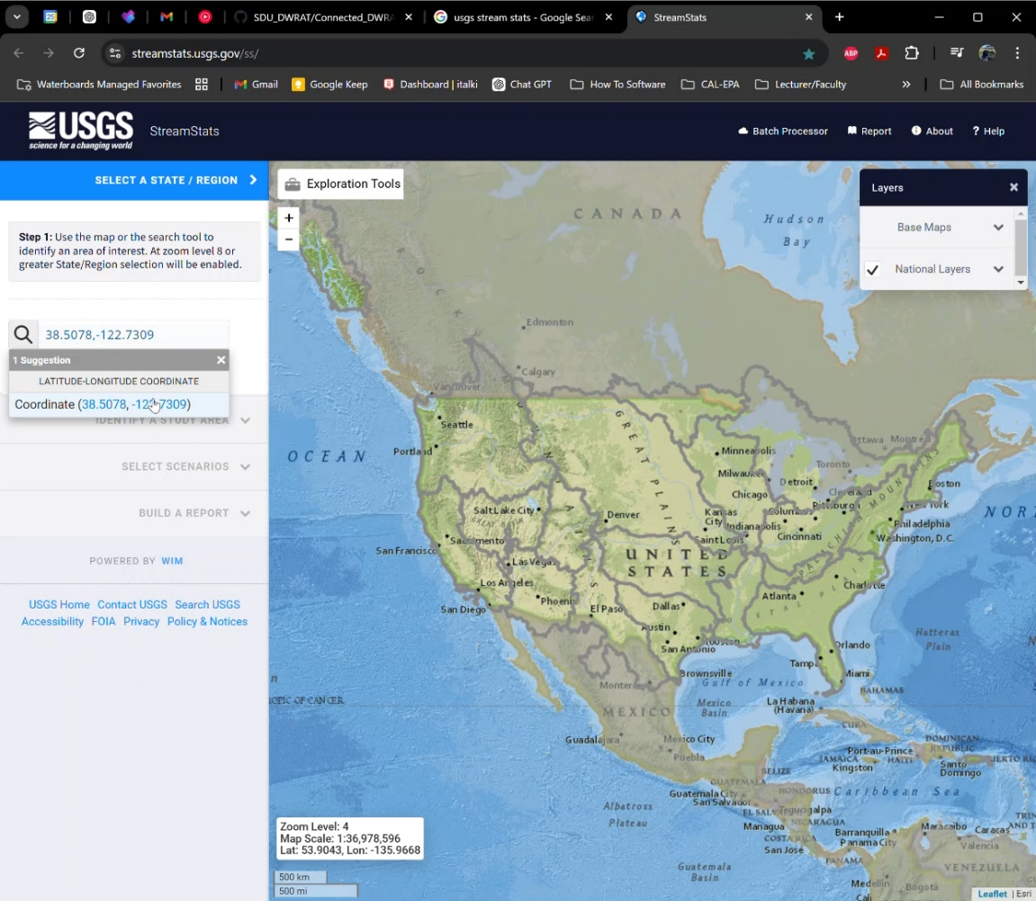

Figure . Coordinate Dropdown option

* 1. Next click *Exploration Tools* and scroll down to *Flow (Raindrop) Path:*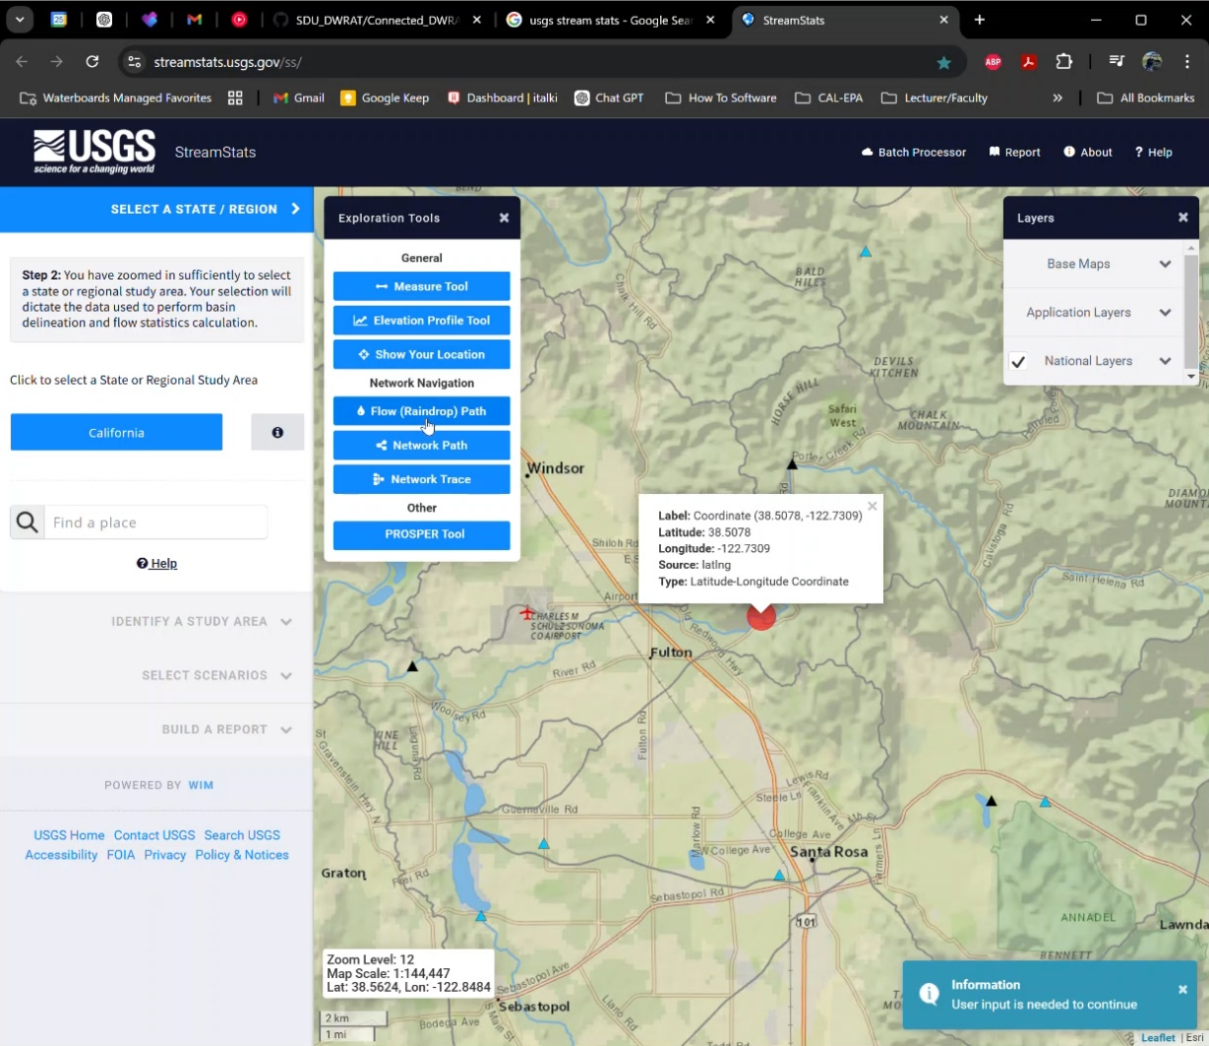

Figure . Flow (Raindrop) Path

* 1. After that, click *Select Point on Map,* pan to the map and then select the red point.

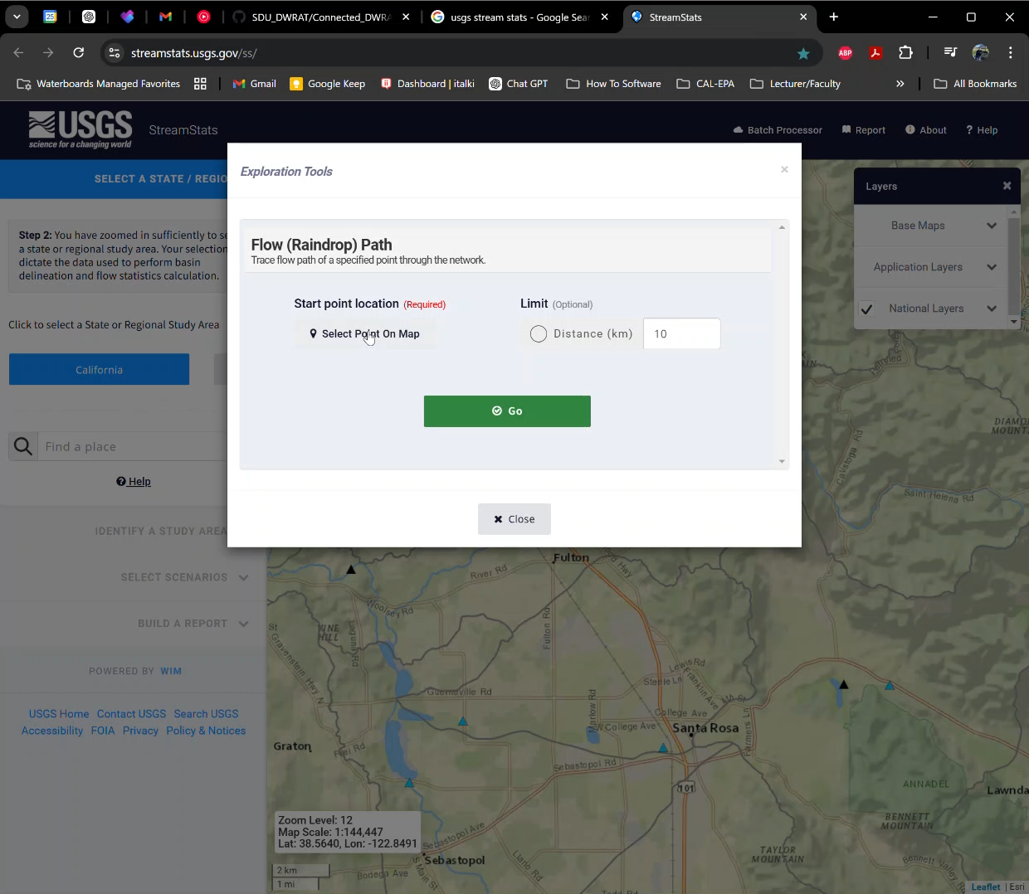

Figure . Flow (Raindrop) Path

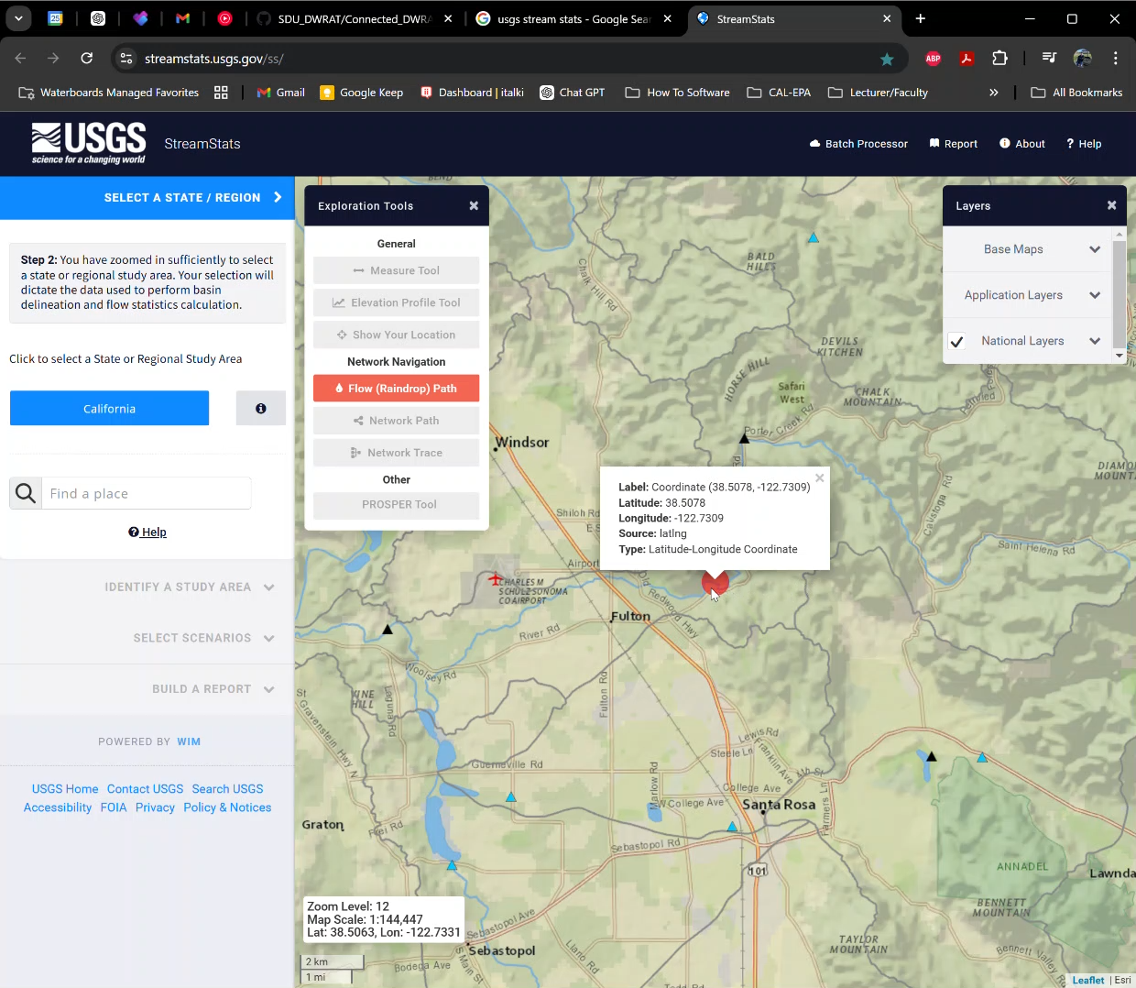

Figure . Selecting the point on the map

* 1. The Flow (Raindrop) Path pop-up menu will re-appear and now click *Go.*

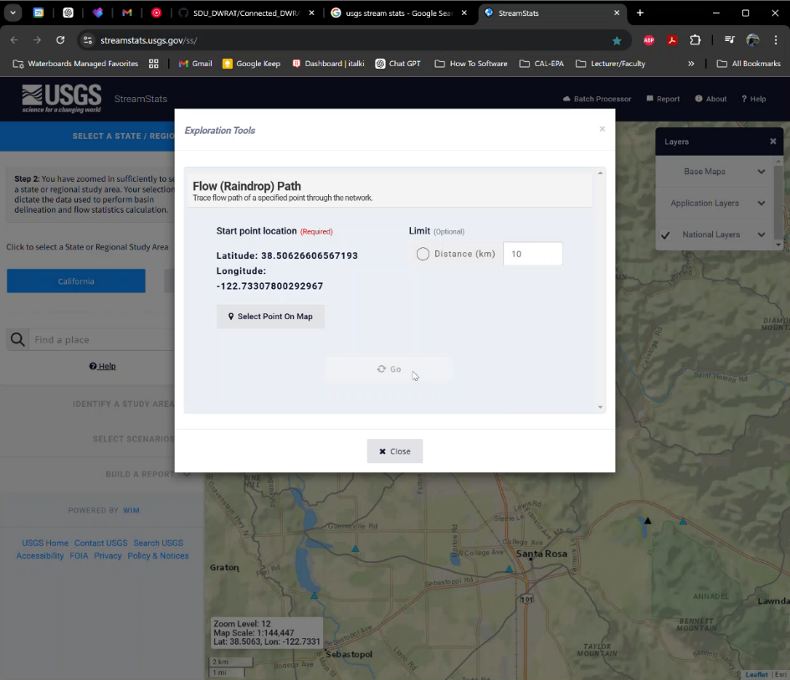

Figure . Flow (Raindrop) Path—Click Go

* 1. Zoom to the end of the red flow path, read the map carefully and confirm that the final watercourse name matches the name of the watershed. In this example, the final watercourse name is the *Russian River*, which confirms that the POD flows into the *Russian River* watershed:

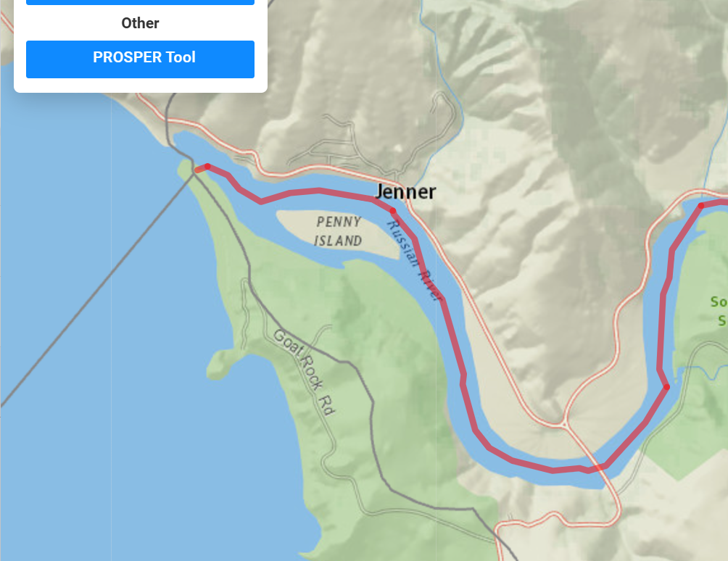

Figure . Watershed Outlet in StreamStats

## Using EarthPoint to convert Northings/Easting into Latitude/Longitude

1. Browse to <https://www.earthpoint.us/StatePlane.aarcgisdspx> and enter these parameters and click *Calc*.

*XY Unit Measure:* Us Survey Feet

*Zone Number*: 0402 or select 0402 – California Zone 2 from the dropdown list.

*Easting/X*: 6282215

*Northing/Y:* 1923229

1. Scroll down the page to find the latitude and longitude in decimal degrees:

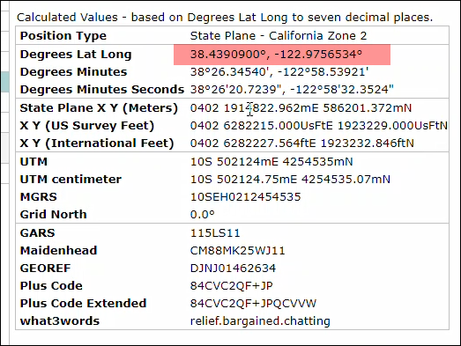

Figure . Northing/Easting Conversion to Latitude and Longitude with Earthpoint

1. In ArcGIS Pro, confirm if your coordinates make sense and match the existing eWRIMS coordinates—navigate to the *Map* tab and click on the *Go to XY* entry tool.

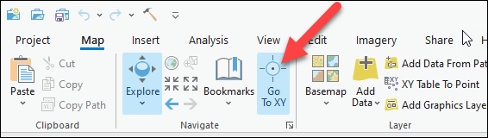

Figure . Go to XY Tool

1. Add an XY label to the map and flash the point. Use the pan and zoom features to bring the point into view. Select the [WS]_pods_manual_review shapefile and look for the nearest PODs. In this case, as [Figure X] demonstrates, the report coordinates match identically with the eWRIMS coordinates for the water right S024280.

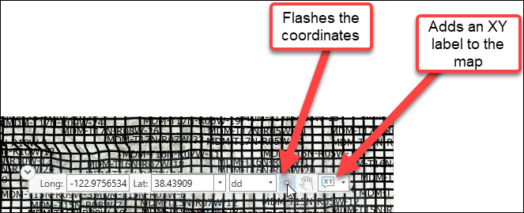

Figure . Features of XY Tool

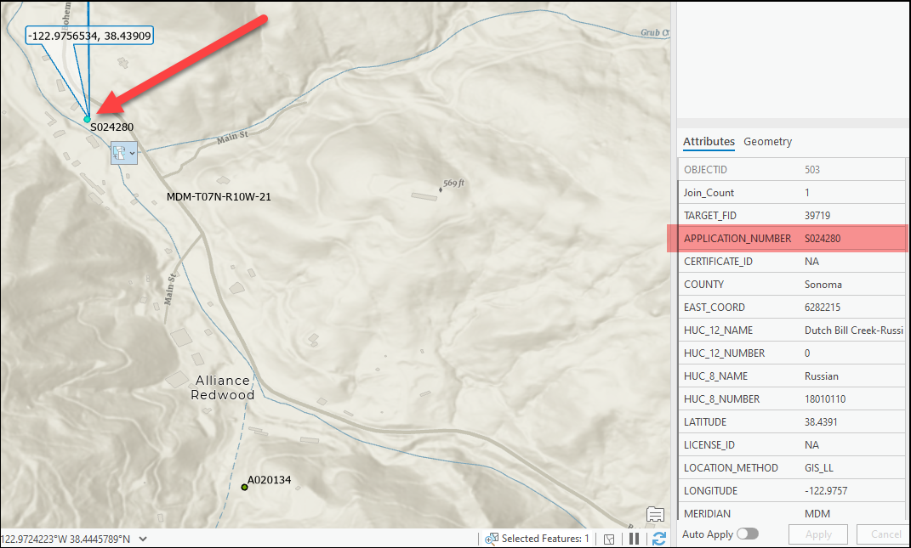

Figure . Comparing eWRIMS coordinates to Report coordinates

1. Type the latitude and longitude that you derived from the EarthPoint website into the *Report_Latitude* and *Report_Longitude* fields but indicate with comments (right-click on each cell to create a comment) that these values were not listed in the report but were derived from the Northing and Easting.

## Finding POD Coordinates in the absence of latitude/longitude and northing/easting

1. Taking water right A028127 as an example, we open the report and look for the POD location description.

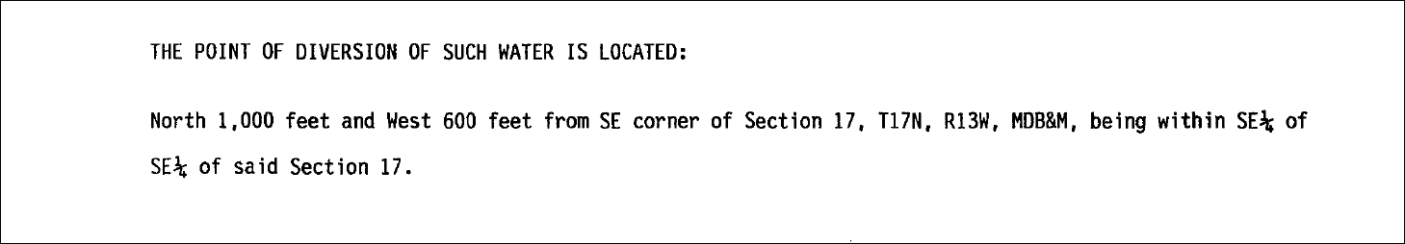

Figure . A028127 POD location description

In this example, no Report_APN is listed but we have sufficient information to pinpoint the POD in eWRIMS because we have values for these fields:

* + - * Report_Meridian: MDBM (“Mount Diablo Base and Meridian”)
      * Report_Township: T17N (or “17N”)
      * Report_Range: R13W (or “13W”)
      * Report_Section: 17
      * Report_QSection: SE (“Southeast”)
      * Report_QQSection: SE
      * Report_POD_Information: North 1000 ft and West 600 ft from SE corner of Section 17, 17N, 13W MDBM—you can you these measurements to pinpoint the exact location in ArcGIS Pro, but you don’t have too—eyeballing the QQSection is sufficient.

1. Make sure that you have loaded these shapefiles into ArcGIS Pro:
   * + - *RR_QQ_Sections* (this is derived from a larger statewide QQ_Section shapefiles but I whittled it down to the Russian River for this example)
       - *PLSS_Sections_Fill_BLM_2024_NAD_1983* (this is the PLSS layer for the entire state of California)
       - *RR_pods_manual_review*
2. You can expedite the process by assuming that the coordinates plotted in eWRIMS are accurate (even though the report itself lacks coordinates); the vast majority of the time, eWRIMS coordinates are correct. This allows us to open the attribute table of the *RR_pods_manual_review* shapefile, select the record for A028127 and zoom to the selected record:

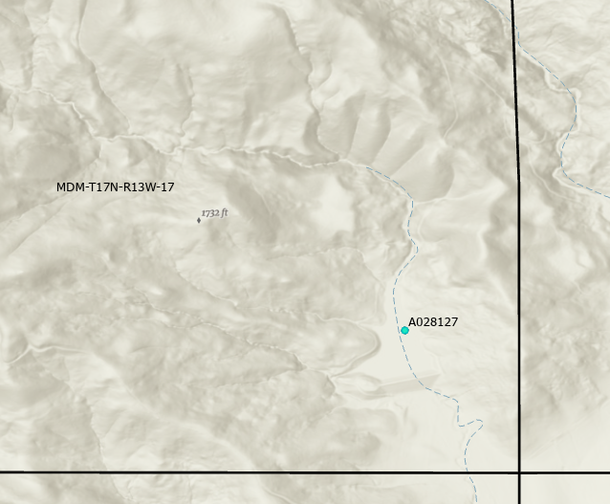

Figure . A028127 POD superimposed on statewide PLSS layer

Figure 50 confirms that the POD is indeed located in Section 17 of Township 17N, Range 13W. If we zoom in, we can visually confirm, as shown in Figure 51, that this POD is located within the SE quarter of Section 17.

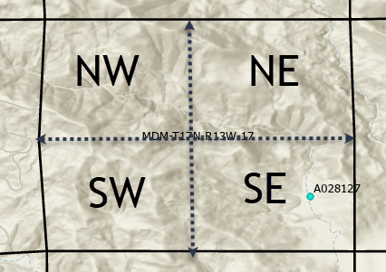

Figure . Dividing Section 17 into Quarter-Sections

After we load the *QQ_Sections* shapefile, and zoom in further, as shown in Figure X, we visually confirm that the POD is located within SE quarter of the SE quarter-section.

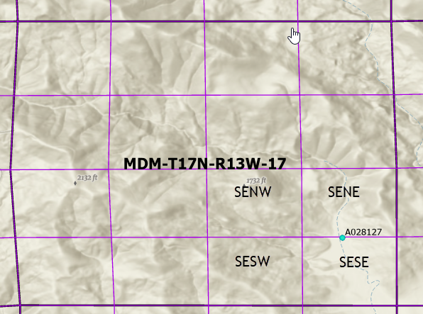

Figure . A028127 superimposed on quarter-quarter sections

For our purposes, this is accurate enough and it validates our initial assumption that the eWRIMS coordinates are accurate. Consequently, we can set the final LATITUDE and LONGITUDE fields in the manual review spreadsheet equal to the eWRIMS_Latitude and eWRIMS_Longitude fields.